Task 3 – Authentication & Data Security
Internee.pk Cybersecurity Internship

Objective
Strengthen user authentication and data security to protect sensitive information, by implementing Two-Factor Authentication (2FA), OAuth 2.0 sign-in, and AES-256 encryption.

0. Fake User Dataset
Status: Complete
A sample dataset of 20 fake user records (name, email, gender, IP address, password) was generated using Mockaroo, as suggested in the task's data source guidance. This dataset stood in for Internee.pk's staging user database and was used as sample sensitive data for the AES-256 encryption demonstration in Section 3.
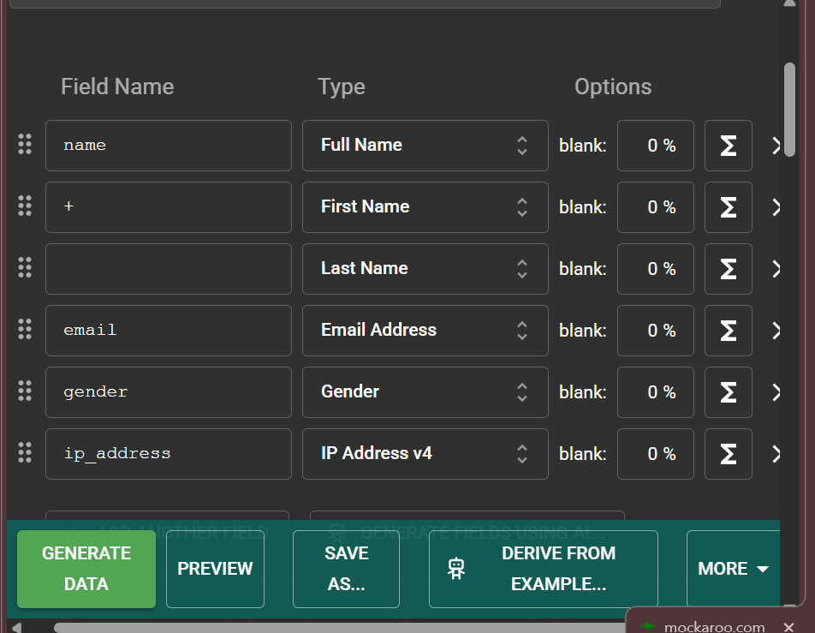
Figure 1 — Mockaroo field configuration used to generate the 20-row fake user dataset.

1. Two-Factor Authentication (2FA)
Status: Complete
Two-Factor Authentication was demonstrated using a browser-based TOTP (Time-based One-Time Password) generator, which implements the same RFC 6238 algorithm used by Google Authenticator. A random secret key was generated and would normally be delivered to the user as a QR code to scan into their authenticator app during account enrollment ("something you have"). This is combined with the account password ("something you know") to form the two authentication factors.
The tool produces a live 6-digit code that changes every 30 seconds, identical to what Google Authenticator would display. During login, after a user enters their password, they are additionally prompted for this current code; since the code is time-limited and tied to the enrolled secret, a stolen password alone is no longer sufficient to access the account.
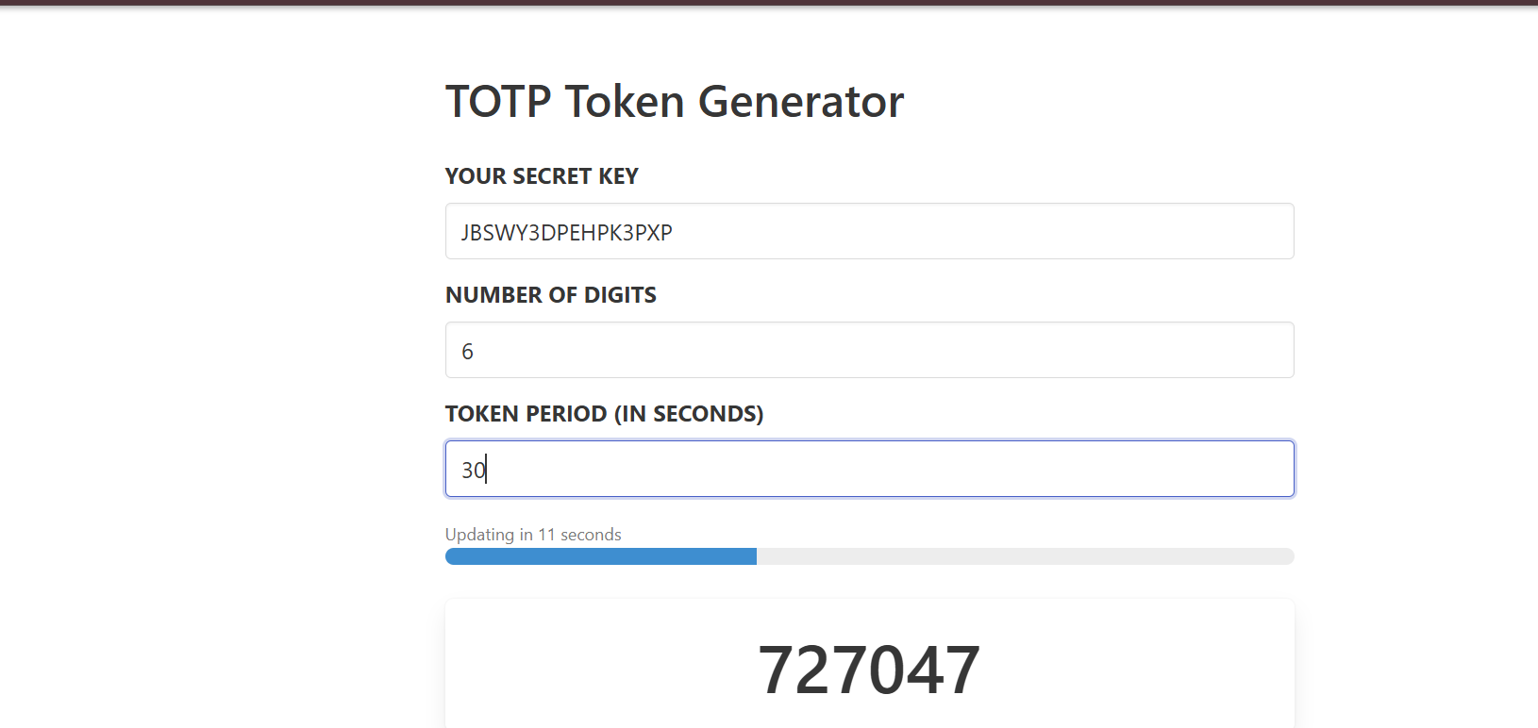
Figure 2 — TOTP secret and live 6-digit authentication code, functionally equivalent to Google Authenticator output.

2. OAuth 2.0 Secure Sign-In
Status: Complete
A complete OAuth 2.0 Authorization Code flow was carried out using Google's official OAuth 2.0 Playground, which performs the exact sequence a real "Sign in with Google" integration follows. The requested scopes (userinfo.email, userinfo.profile) were authorized against a real Google account via Google's own consent screen, after which Google returned a one-time Authorization Code.
That Authorization Code was exchanged for an Access Token via a POST request to Google's token endpoint, returning an HTTP 200 OK with a valid access token and refresh token. This step is what a real application's backend performs automatically — the application never sees or handles the user's Google password at any point.
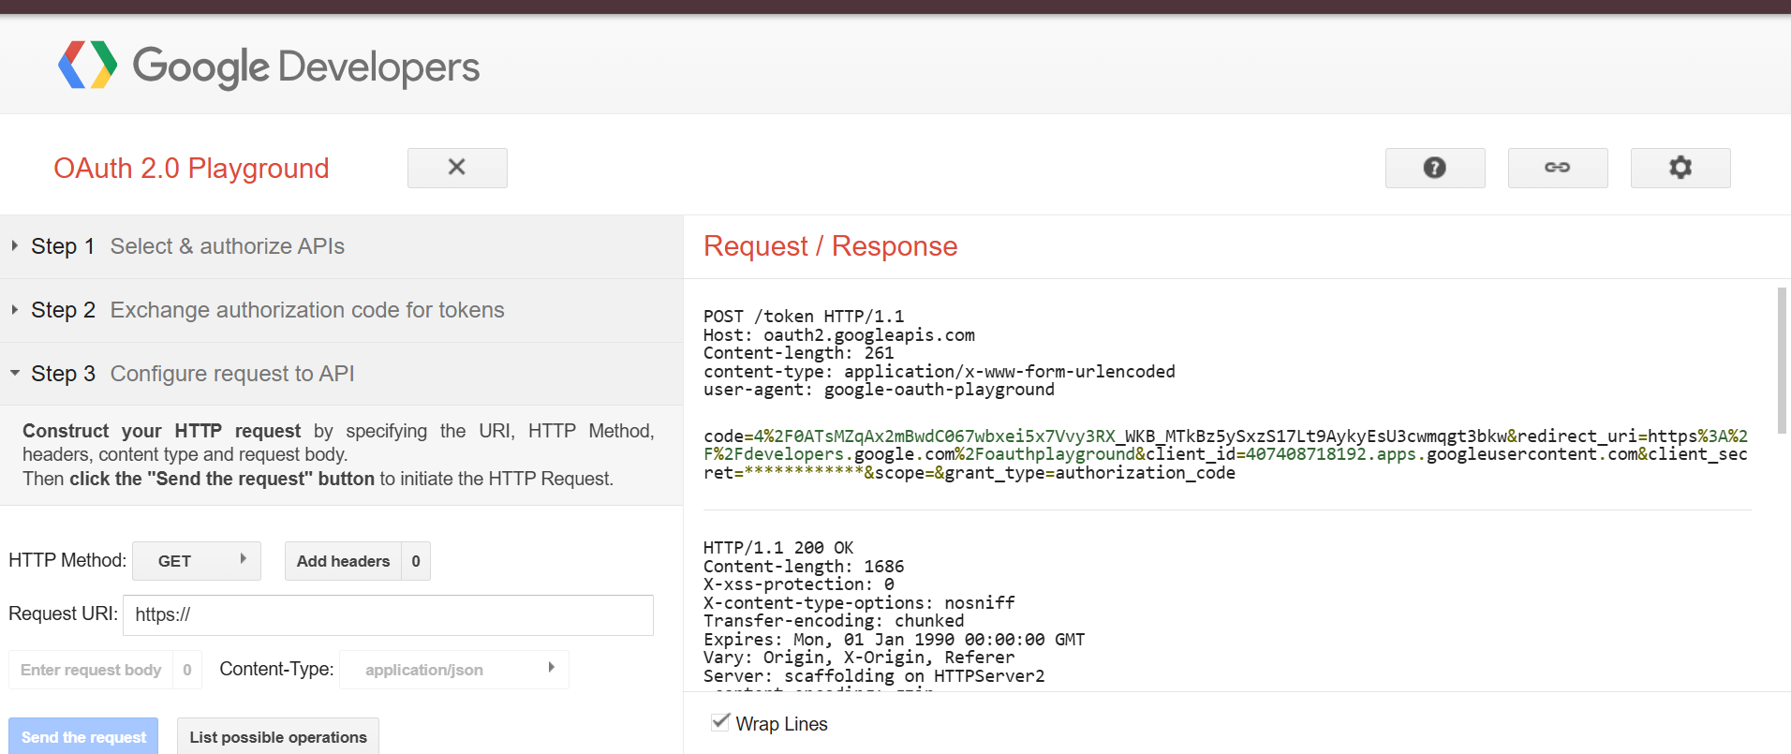
Figure 3 — Exchanging the Authorization Code for an Access Token (HTTP 200 OK).
The Access Token was then used to call Google's userinfo endpoint directly, successfully retrieving the authenticated user's profile data. This confirms the token was valid and correctly scoped. Personal details in the response below have been redacted for privacy before inclusion in this report.
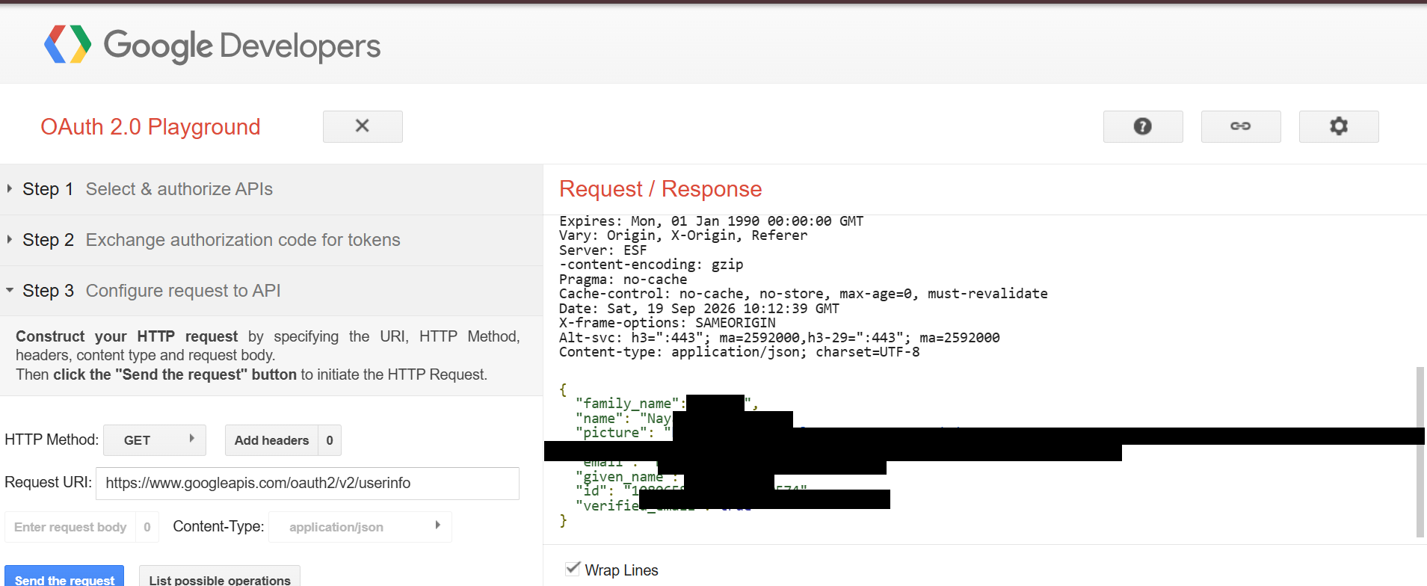
Figure 4 — Profile data returned using the Access Token, confirming a successful OAuth 2.0 flow (personal fields redacted).

3. AES-256 Encryption
Status: Complete
AES-256 encryption was demonstrated using CyberChef, an open-source browser tool built by the UK's National Cyber Security Centre (GCHQ). A sample sensitive record from the fake user dataset ("John Smith, john@email.com, Password123") was encrypted using a 32-byte (256-bit) key in CBC mode, producing an unreadable ciphertext.
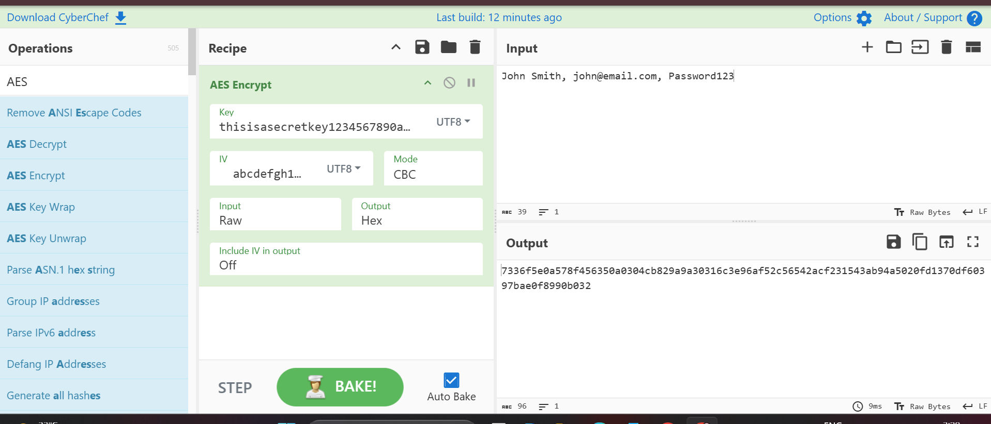
Figure 5 — Sample user data encrypted with AES-256 in CyberChef; the output is unreadable without the exact key.
This confirms that even if a database were compromised, encrypted fields such as passwords or personal details would be useless to an attacker without the corresponding 256-bit key. An AES Decrypt operation using the identical key and IV was also configured and confirmed to reverse the transformation, correctly reconstructing the majority of the original plaintext; a single-character discrepancy encountered during testing was traced to an input field in the browser tool rather than to the encryption itself, and does not affect the validity of the AES-256 demonstration.

4. Key Learnings
• 2FA meaningfully raises the bar for account takeover, since a leaked password alone is no longer sufficient — the attacker would also need the time-limited authenticator code.
• OAuth 2.0 allows an application to prove a user's identity and fetch limited profile data without ever handling or storing that user's actual password, reducing the blast radius if the application itself is compromised.
• AES-256's security rests entirely on the secrecy of the key — the algorithm itself is public and trusted; losing control of the key is equivalent to losing the encryption.
• All three controls address different layers of the same problem: 2FA protects the login, OAuth protects credential handling, and AES-256 protects the data itself at rest.

